Part One
In this assignment, PostgreSQL and DBeaver were used to integrate multiple food and nutrient data sets. The assignment involved creating database tables, loading CSV files into PostgreSQL, establishing relationships between tables using primary and foreign keys, validating the database using sentinel queries, and executing SQL queries to identify healthy foods.
1) Relational Schema Design
The relational schema was designed based on the structure of the Child Nutrition Database documentation. The schema includes six tables connected through primary key and foreign key relationships.
Tables Used
CTGNME: Stores food category descriptions.
GPCNME: Stores Global Product Classification category descriptions.
FDES: Stores detailed food item descriptions.
NUTDES: Stores nutrient descriptions and units.
NUTVAL: Stores nutrient values for food items.

WGHT: Stores serving size and weight information.

2) Primary Keys and Foreign Keys
The following primary keys were implemented:
Table | Primary Key
CTGNME | Food category code
GPCNME | Gpc code
FDES | Cn code
NUTDES | Nutrient code
NUTVAL | (Cn Code, Nutrient code)
WGHT | (Cn code, Sequence num)
The following foreign keys were implemented:
Child Table | Foreign Key | Parent Table
FDES | Food category code | CTGNME
FDES | Gpc product code | GPCNME
NUTVAL | Cn Code | FDES
NUTVAL | Nutrient code | NUTDES
WGHT | Cn code | FDES

Index Design
Indexes were created automatically through primary key constraints. These indexes improve query performance when executing sentinel queries and joining tables. The most important indexed columns were: Cn code, Nutrient code, Food category code, Gpc code

3) Database Implementation
The database was implemented using PostgreSQL and DBeaver inside the Codio environment. Tables were created manually using SQL CREATE TABLE statements.

4) ETL Process
The ETL process included extracting the CSV files, transforming the column structure, and loading the data into PostgreSQL.
5) Sentinel Query Validation
Sentinel queries were executed to verify that all records were successfully loaded into the database.
1) select count(*) from fdes;
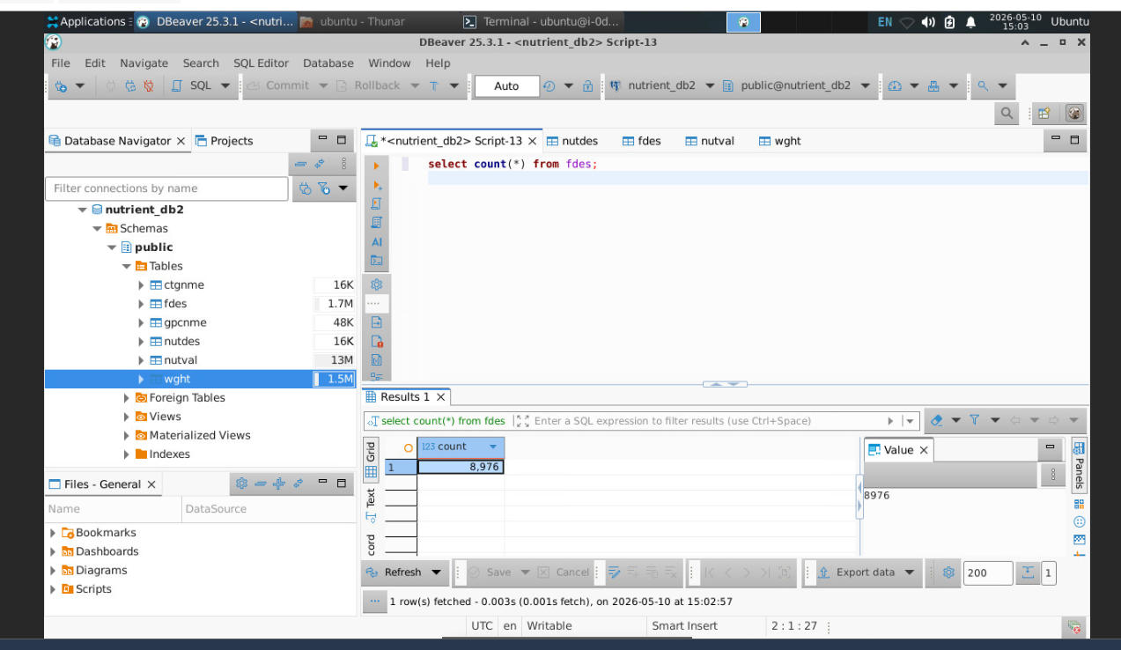
2) select count(*) from wght;
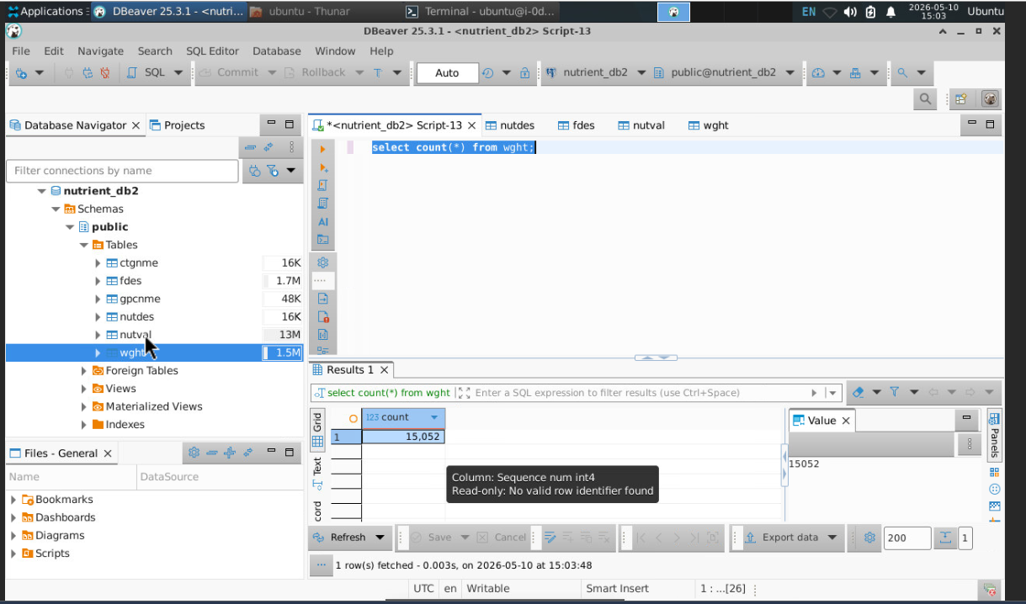
3) select count(*) from gpcnme;
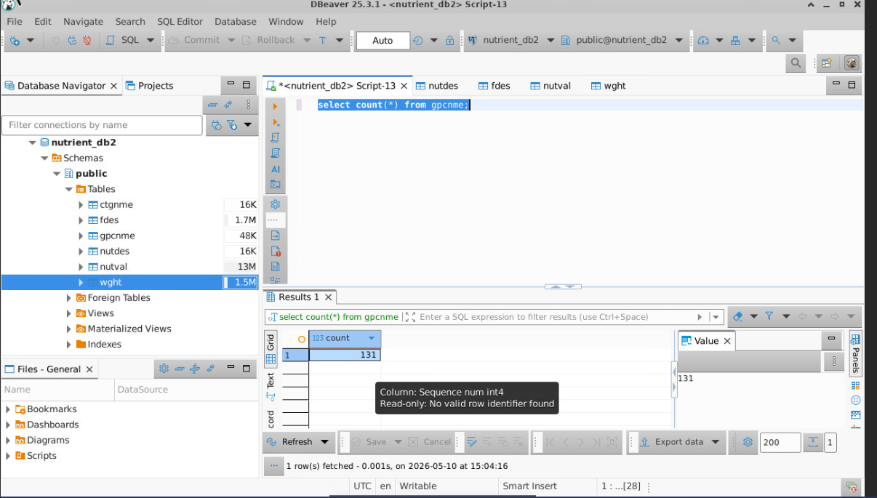
4) select count(*) from ctgnme;
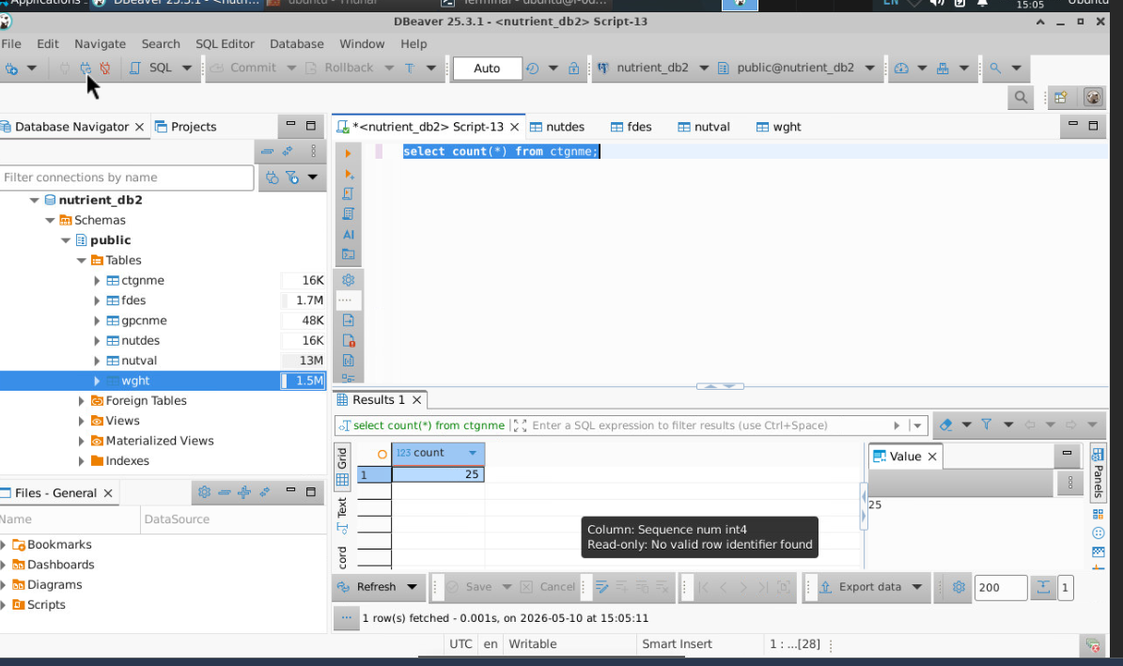

Healthy Food Queries
Two SQL queries were developed to identify healthy food items.

Query 1: Top Protein Foods with Low Fat
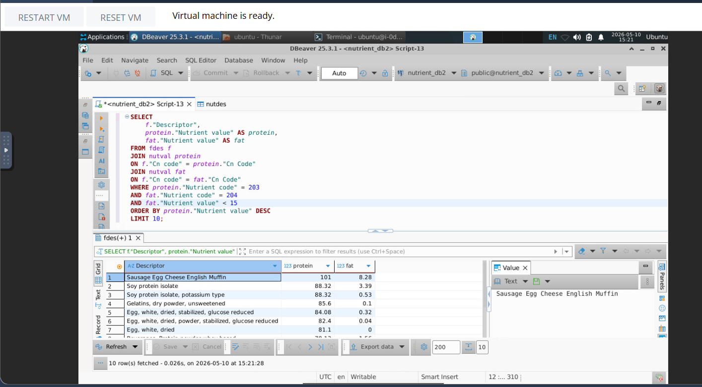
This query identifies foods with high protein values while keeping total fat below 15 grams.

Query 2: Top Vitamin C Foods with High Protein


Part Two

1) Entity Relationship Diagram (ERD)
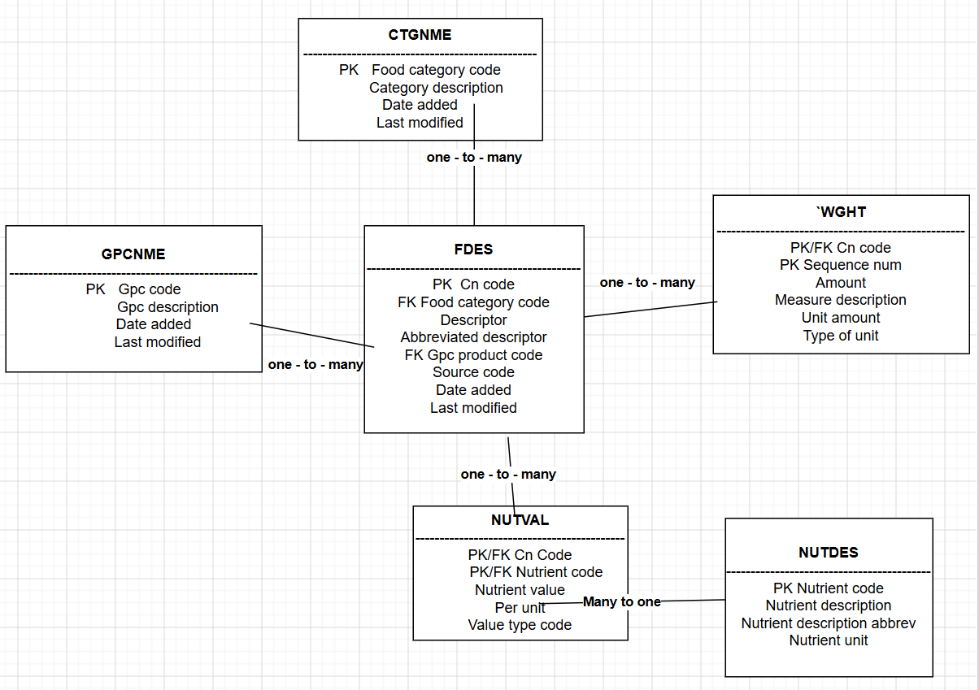

2) ERD Description
The ERD diagram visually represents how the six tables are connected.
- The FDES table is the main table because it stores the primary information about food items. The CTGNME table provides category descriptions for foods, while the GPCNME table stores product classification information.
- The NUTVAL table connects food items with nutrient information, and the NUTDES table provides descriptions for each nutrient code. The WGHT table stores serving size and measurement information for food items.
- Relationships between the tables were implemented using foreign keys.

3) Schema Design Justification
- The schema was designed using relational database normalization principles.
- Primary keys were selected to uniquely identify each record in the database. Composite primary keys were used in the NUTVAL and WGHT tables because multiple records can exist for the same food item.
- Foreign keys were used to connect related tables and maintain referential integrity.
- The TEXT data type was used for date fields because the CSV files contained inconsistent date formatting. Using TEXT simplified the ETL process and prevented import failures.
- The schema design improves data consistency and supports efficient SQL joins between tables.
This assignment provided practical experience in relational database design, ETL processing, PostgreSQL implementation, and SQL query development. Using PostgreSQL and DBeaver, the Child Nutrition Database was successfully integrated into a relational schema. Primary keys and foreign keys were implemented to maintain relationships between tables. Sentinel queries validated successful data loading, and SQL queries were used to analyze healthy foods based on nutrient values.

